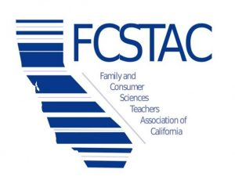
Education, Child Development, and Family Services
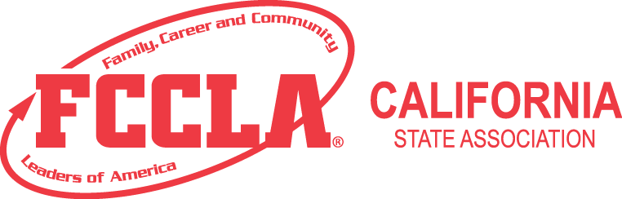
Fashion and Interior Design
Hospitality, Tourism, and Recreation

Family and Consumer Sciences (FCS) and Family and Consumer Sciences Related Occupations (FCSRO) instructional programs are based on the eight content areas of the Family and Consumer Sciences Body of Knowledge:
- Child Development and Guidance
- Consumer Education
- Family and Human Development
- Fashion, Textiles, and Apparel

- Food and Nutrition
- Housing and Furnishings
- Individual and Family Health
- Leadership Development

Two Credentials to Teach FCS Industry Sector Courses, Grades 7 – 12
1. Single Subject Teaching Credential - Home Economics (FCS)
- Hold a Family and Consumer Sciences B.A. or B.S. degree OR Major in a related field (such as Child Development or Nutrition) and pass the CSET to confirm subject area proficiency, AND either
  - Complete a fifth year credential program consisting of curriculum and instruction coursework and student teaching, OR
  - Apply for an Internship program where you complete the curriculum and instruction coursework during a two-year paid internship (instead of student teaching; must find your own teaching position).
OR
- Hold a Single Subject Credential in another subject area, pass the CSET to add Home Economics as a supplementary authorization, and complete a Home Economics Methods course (Sacramento State offers this course online – usually in the summer).
2. Designated Subjects CTE
- Authorizes teaching in one or more of the three FCS industry sectors, depending on college coursework and industry experience:
  - D. S. CTE - Education, Child Development, and Family Services
  - D. S. CTE - Fashion and Interior Design
  - D. S. CTE - Hospitality, Tourism, and Recreation
- Qualification Option A: Complete 48 semester units of postsecondary vocational training related to the industry sector(s) named on the credential (courses or majors such as Nutrition, Child Development, Hospitality Management, Education, Family Services, Fashion Design, Interior Design, Culinology, or Apparel Design and Merchandising) AND Have one year (1000 hours) of work experience in the industry named on the credential.
OR
- Qualification Option B: Have a high school diploma and three years of related industry experience.
One of the following may be used as one year of work experience: Possession of an advanced industry certificate related to the industry sector to be named on the preliminary credential, as determined by a Commission-approved CTE program sponsor OR One year of full-time general education teaching experience providing instructional services in preschool or grades K-12 earned in a public or private school of equivalent status
Single Subject Credential
Where? The following institutions offer Single Subject Credential programs in California:
- CSU Sacramento (on campus; fifth year; spring internship available)
  - http://www.csus.edu/coe/academics/credentials/index.html
- CSU Northridge (on campus; fifth year and internship available)
  - (818) 677-2733
  - https://www.csun.edu/eisner-education/secondary-education/preliminary-single-subject-credential-program
- CSU Bakersfield (on campus; internship available)
  - http://www.csub.edu/sse/credentials/index.html
  - (661) 654-2110
- Teachers College of San Joaquin, IMPACT Program (on campus; internship available)
  - (209) 468-9132
  - teacherscollegesj.edu
- Brandman University (online; some courses on one of their 30 campuses)
  - (949) 341-9899
  - https://www.brandman.edu/academic-programs/education/2042-teaching-credential-single-subject
- Tulare County Office of Education, IMPACT Program (on campus; internship available)
  - http://www.tcoe.org/NTLD/
  - (559) 730-2549
Designated Subjects CTE Credential
Where? Nearly every County Office of Education in California processes D.S. CTE credentials. The following institutions have been confirmed by telephone:
- CSU San Bernardino offers B.S and B.A. in Career Technical Studies and the Designated Subjects CTE Credential: https://coe.csusb.edu/career-technical-education/teaching-credentials/career-technical-education-cte
- Teachers College of San Joaquin (on site; internship)
- San Diego County Office of Education (Online; internship): http://www.sdcoe.net/human-resources/credentials/Pages/default.aspx (858) 292-3507
- Los Angeles County Office of Education: https://www.lacoe.edu/CurriculumInstruction/CareerTechnicalEd/CTECredentials.aspx
- Lake County Office of Education: http://www.lake-coe.k12.ca.us/programs/human_resources
- Ventura County Office of Education: http://www.vcoe.org/ess/dsc
- Tehama County Department of Education
- Tulare County Office of Education
- Sonoma County Office of Education
- Sutter County Superintendent of Schools
- Orange County Department of Education
- Davis Joint Unified School District
- UC Berkeley Extension: https://extension.berkeley.edu/public/category
- Fresno Pacific University: https://www.fresno.edu/programs-majors/designated-subjects-education/career-technical-education
- UC Riverside Extension: https://www.extension.ucr.edu/certificates/9698690

