HECT Philippe Caillot

Garlic Tuile:

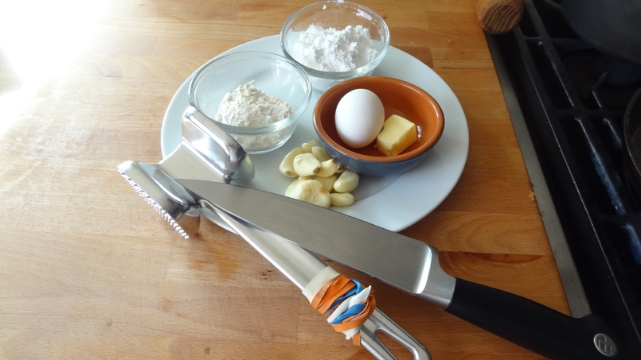

40 gr Powdered Sugar
20 gr Flour
2 ea Egg white
10 gr Butter
1.5 oz Garlic cloves

- Blanch garlic (3 times) in cold water

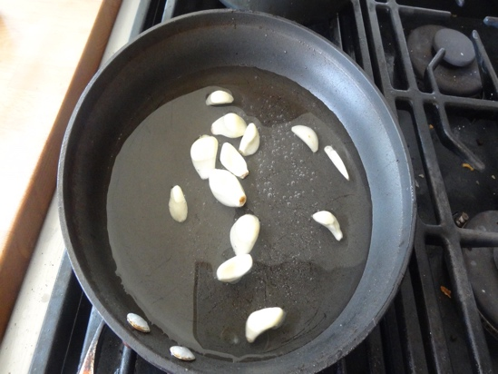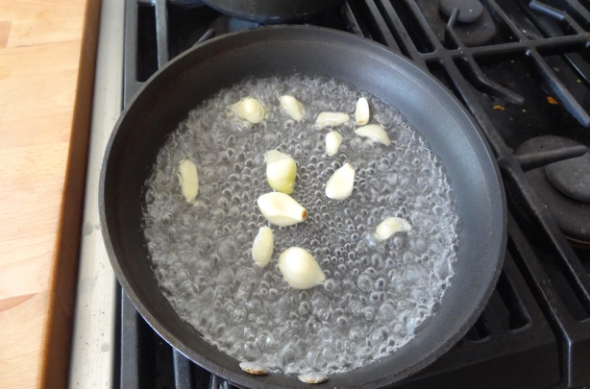

- Crush garlic between 2 pieces of plastic sheet

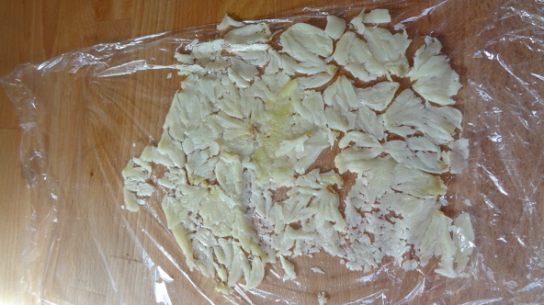

- Mix powder sugar, egg whites and garlic together

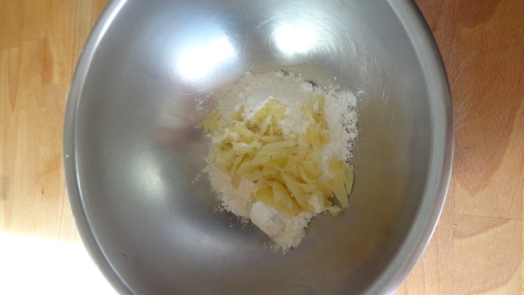
- Make beurre “noisette”
- Add to previous mixture
- Spread mixture on silpat with a wet fork or spoon

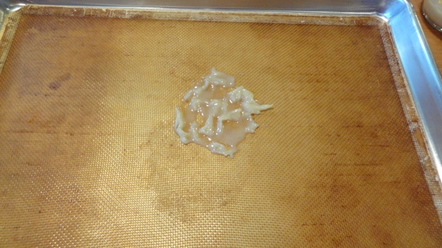
- Cook at 425 F until the edges brown slightly
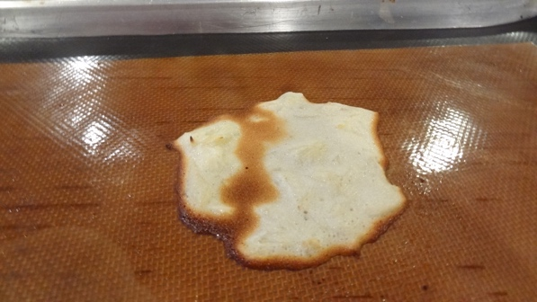
- Place on rolling pin or tuile gutter until if cools

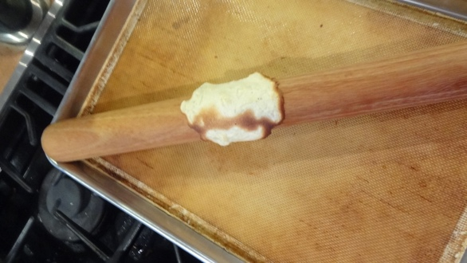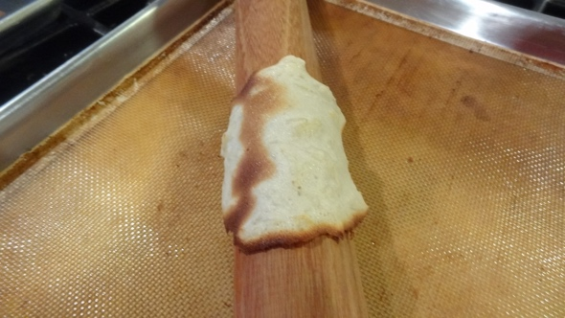
- Enjoy
